Chuff Me Native Android Development

# Overview

Purpose of this document is to discuss some of the technical issues raised from developing the Chuff Me Android App.

<https://github.com/kanemars/ChuffJava>

<https://play.google.com/store/apps/details?id=kanemars.chuffjava&hl=en_GB>

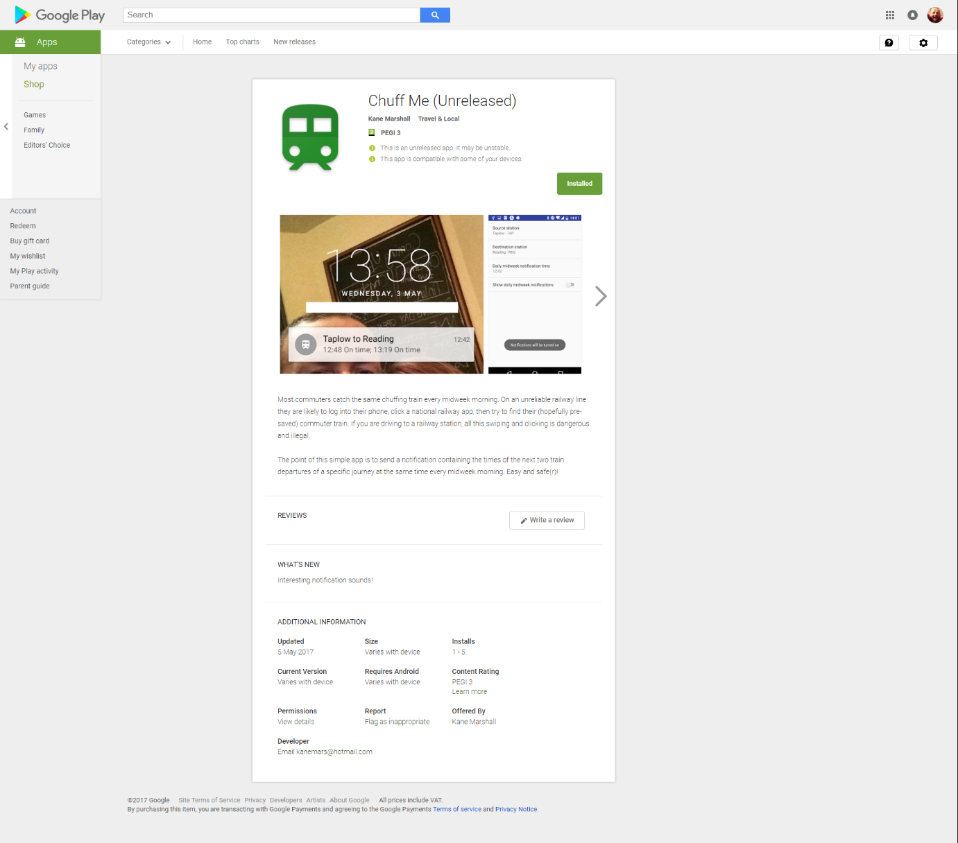

# Deploy to Play Store

Steps:

1. Look in file build.gradle at the versionCode and versionName section and increment them.
2. Intellij Version under Build🡪Generate Signed APK 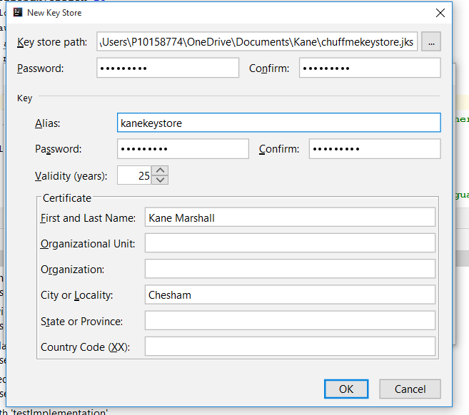 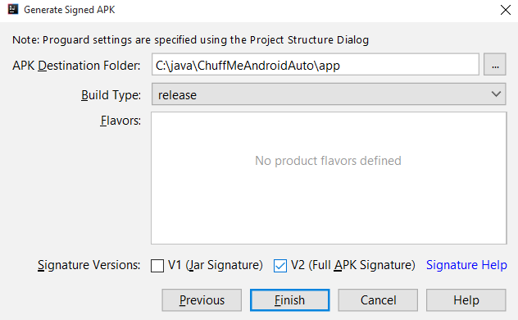
3. Upload (C:\java\ChuffMeAndroidAuto\app\release\app-release.apk) to Google Play Developer
   1. Press the button Create Release
4. Update section *What's new in this release?*
5. Review and roll out

# Install app via USB

In IntelliJ you can click the run button then choose the USB connected phone to install the app.

## To run via USB on Xiaomi Rednote 4

I *might* have had to install Mi PC Suite in order for the phone to trust the PC, but the software has a major bug in it.

Ensure the key options below are selected:

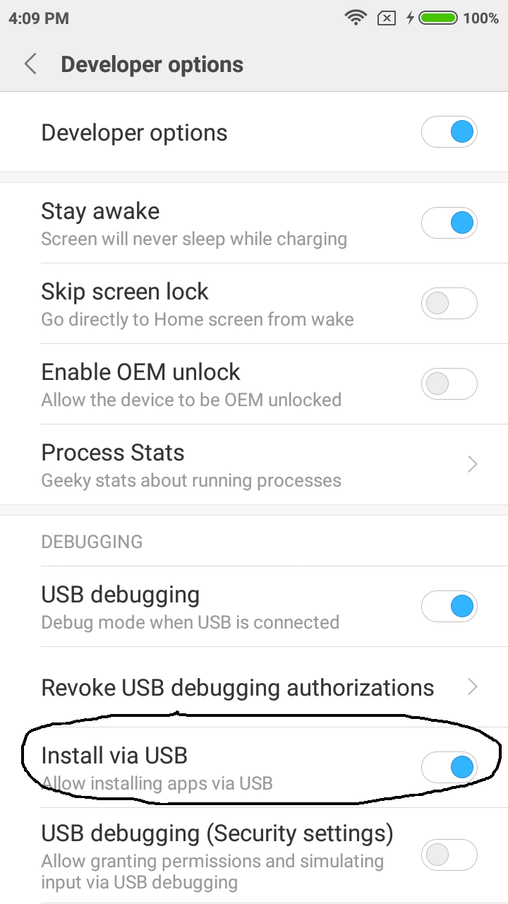

## If device cannot be found

C:\Users\P10158774\AppData\Local\Android\android-sdk\platform-tools>adb kill-server

C:\Users\P10158774\AppData\Local\Android\android-sdk\platform-tools>adb start-server

# Notifications

By far the most difficult functionality to implement was showing repeating notifications at the right time and for the following scenarios:

1. When app is launched by the user, only want to show notification if
   1. the user has turned notifications on within the settings screen, and
   2. only at the time they have specified on the settings screen(and then every day forthwith of that time)
2. When Android is rebooted, only show notification if the saved preferences show notifications are turned on, and only at the time specified in the saved preferences
3. For above 2 scenarios, don’t want 2 streams of notifications going off. There should only be one alarm manager in “memory”

# Stopping the repeating notifications

## For the notifications created under the MainActivity

The following code stops the notifications.

**alarmMgr**.cancel(**pendingIntent**);

### Steps to replicate

1. Install app
2. Set notification time to start in 2 minutes from now
3. Turn notification toggle to on
4. Wait for at least 2 notifications to display
5. Turn notification toggle to off
6. There should be no further notifications

## For the notifications created under StartAtBootReceiver

Currently StartAtBootReceiver is starting its own repeating notifications, separate to the MainActivity. Some strategies for the MainActivity to stop the StartAtBootReceiver repeating notifications:

1. Find some way for MainActivity to stop the notifications that were started in StartAtBootReceiver.
2. The StartAtBootReceiver calls the same repeating notifications code in the MainActivity. Perhaps there is a way to start MainActivity without it appearing on the screen? Google BroadcastReceiver starting MainActivity without it appearing on screen?

# If notifications turned off then on again don’t start until first notification time

1. Set notification time to start in 2 minutes from now (let’s say it is 16:57 now so set to 16:59)
2. Turn notification toggle to on
3. Wait for at least 2 notifications to display
4. Turn notification toggle to off and wait a minute
5. Turn notification toggle back to on and we shouldn’t hear a first new notification until 16:59 the next day, we don’t want to have a notification before that time

Answer [here](https://stackoverflow.com/questions/16870781/fire-notification-at-every-24-hours-and-at-exact-time-of-8-am). You basically have to add a day on if the time chosen is before now.

# Support Chuff Me in Android Auto

## Install DHU

This application would work brilliantly in Android Auto. The new Android SDK interface has changed, you can find it in Android Studio 3.0 --> Settings. Android Auto Desktop Head Unit emulator needs to be downloaded.

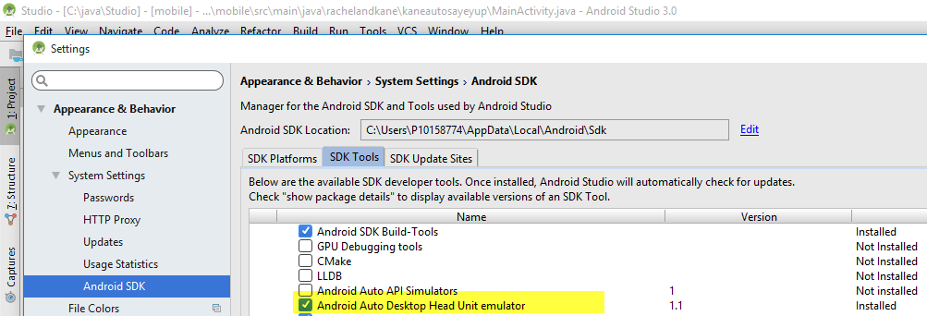

## Run the DHU

Then follow complex [instructions](https://developer.android.com/training/auto/testing/index.html).

1. On the phone, enable developer mode by tapping on the About Android Auto title several times quickly.
2. Then click on Start Head Unit.

Connect your android phone via USB and then check to see if its attached as below:

C:\Users\P10158774\AppData\Local\Android\Sdk\platform-tools>adb devices

List of devices attached

7b0cc2e8 device

Then type

C:\Users\P10158774\AppData\Local\Android\Sdk\platform-tools>adb forward tcp:5277 tcp:5277

Android Auto about 🡪 Start Head Unit server

In a different directory run:

C:\Users\P10158774\AppData\Local\Android\Sdk\extras\google\auto>desktop-head-unit

Connecting over ADB to localhost:5277...connected.

>

## Create a new “card” on the Auto Homescreen

Currently Auto shows Music, Navigation and Weather “cards”.

I wonder if I can show a navigation card which shows train information.

I read [this](https://www.xda-developers.com/android-auto-2-3-hints-at-a-redesign-of-the-home-screen-cards/) article which hinted at experimental cards, but not available yet.

## Show notification on Android Auto

Here’s how a SMS appears in Auto:

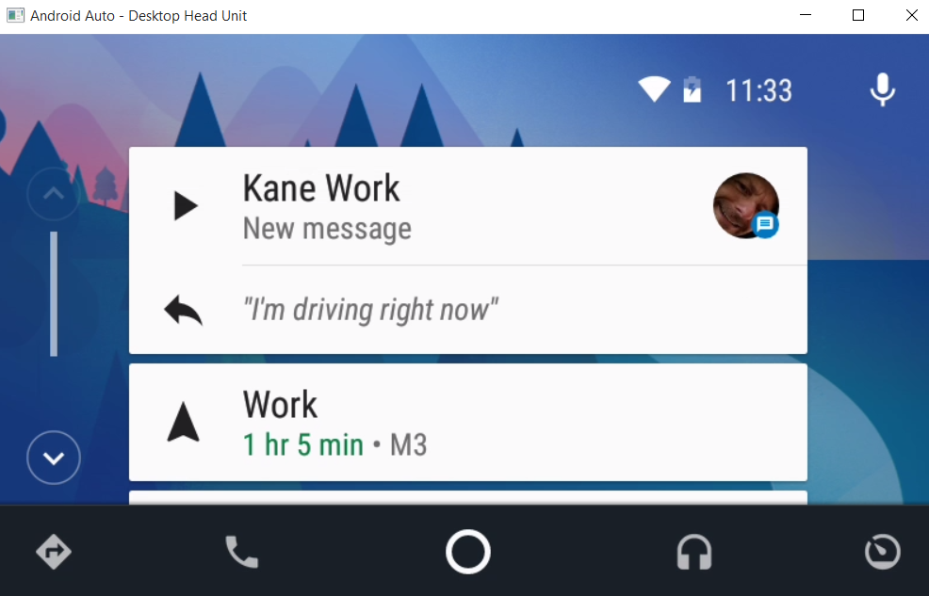

Need to get the simplest app to send a [notification](https://classroom.udacity.com/courses/ud875C/lessons/4393630137/concepts/44145586160923). There’s a tutorial that has the following screenshot in the video.

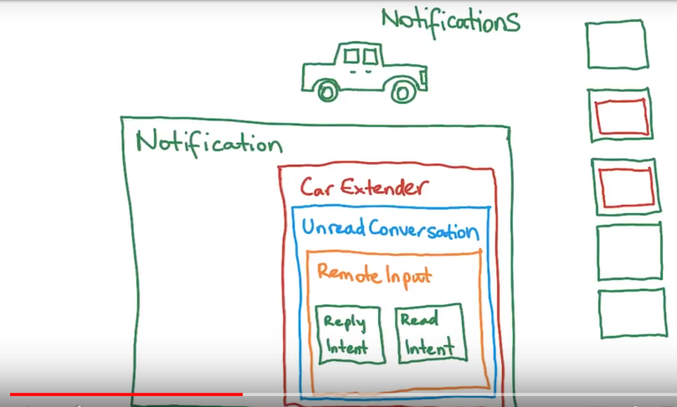

Looks like the Chuff Me notification should extend or include the CarExtender.

With your basic Android App you can Import Sample Project, basic notification.

To get the notification to show up as shown in the below screenshot you need to add

<**meta-data android:name="com.google.android.gms.car.application"  
 android:resource="@xml/automotive_app_desc"**/>

to AndroidManifest.xml and the automotive_app_desc is like…

<**automotiveApp**>  
 <**uses name="notification"**/>  
</**automotiveApp**>

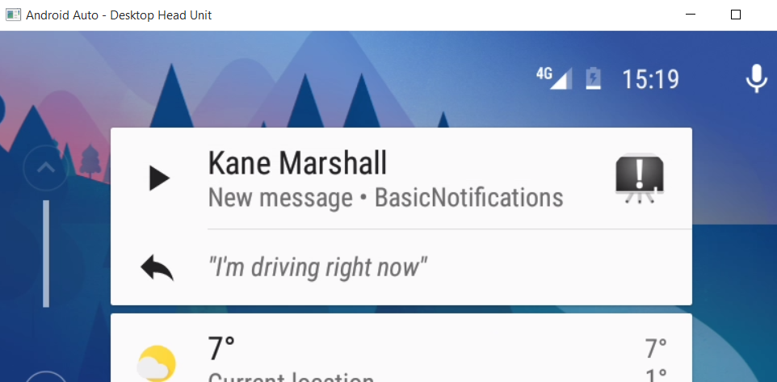

The idea is you won’t want to be reading a message whilst you are driving. So the “New message” is not configurable.

However, the “Kane Marshall” could be changed to “Trains on time” or “7:24 7.26; On time” like normal chuff me application and the icon could change depending upon whether the trains are on time.

## Trigger a notification when Android Auto starts

Chuff Me app should ideally launch as a standard “card”. As I don’t know how to do this, I could trigger a notification that will start when android auto starts.

How about the [Automate](https://play.google.com/store/apps/details?id=com.llamalab.automate&hl=en) app? I created the following flow *Show Chuff Me in Android Auto*:

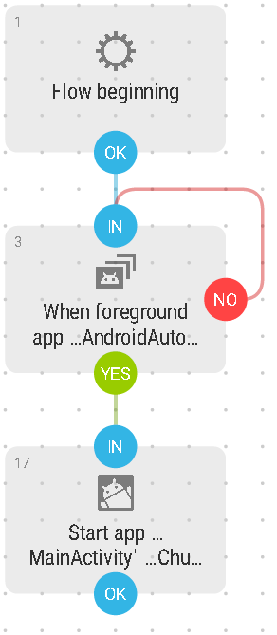

Now I can modify this version to actually show some useful information. And one day I will programmatically do the above flow.

## Allow Chuff Me to be launched via OK Google

Android Auto starts when it detects your car is moving. Another option to start Chuff Me is to launch it via OK Google.

According to [makeuseof](http://www.makeuseof.com/tag/ok-google-20-useful-things-you-can-say-to-your-android-phone/), you say “open” followed by the name of the app.

Interestingly it interprets “Chuff Me” as “Trust Me”. So I changed name of app to Fizzling Fireboxes and now you can launch the app from the phone, which in turn sends a notification.

However, when you then try to “Open Fizzling Fireboxes” via Android Auto, the audio response is “sorry, I don’t understand that”.

Check out your [OK Google voice and audio history](https://myactivity.google.com/myactivity?restrict=vaa&hl=en-GB&utm_source=udc&utm_medium=r&utm_campaign=). These are specifically the commands I used via Android Auto.

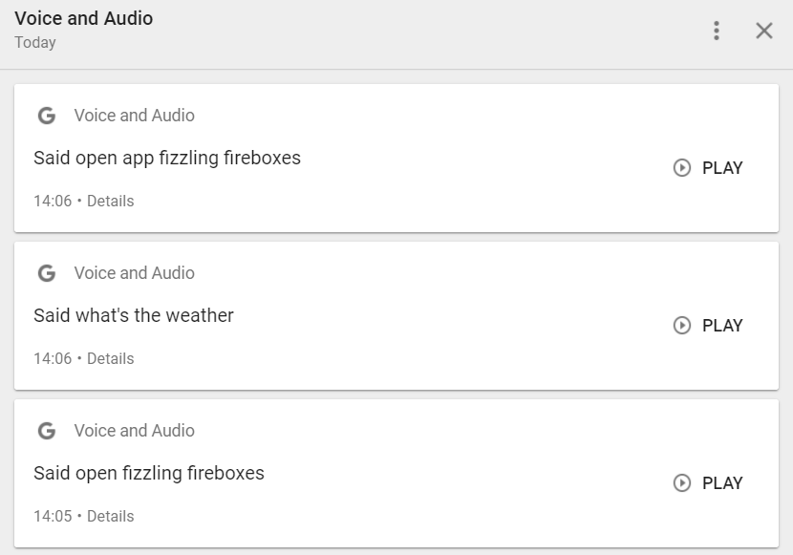

Is it a known problem? I tried this workaround:

F,{2c606ed4-4a95-416d-a2a2-7e1aed6fdcc8}{243},3.125,3.125

# Problems

## Cannot resolve symbol AppCompatActivity

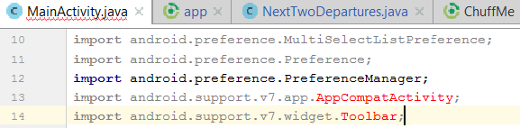

In build.gradle you have to look at the dependencies.

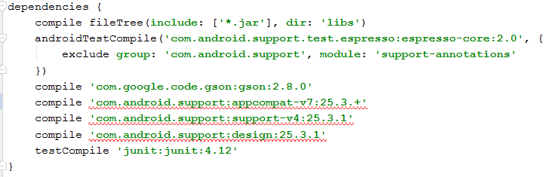

A recommendation is File >Invalidate Caches & Restart -> Invalidate & Restart.

I gave up and instead downloaded a stable release of ChuffMe from github.

## Cannot resolve symbol ‘R’

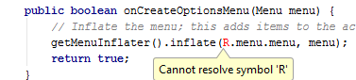

Tried File >Invalidate Caches & Restart -> Invalidate & Restart

What worked for me was reverting all changes.

## adb server version (36) doesn't match this client (39); killing...

adb kill-server

adb start-server

## 0123456789ABCDEF offline

First of all, 0123456789ABCDEF may be simply the phone’s serial number, as it is with my Uhans Max 2.

The status might change to “device” if you unplug the USB then replug it.

## Get var to work

<https://stackoverflow.com/questions/49581032/local-variable-type-inference-not-being-recognized?utm_medium=organic&utm_source=google_rich_qa&utm_campaign=google_rich_qa>

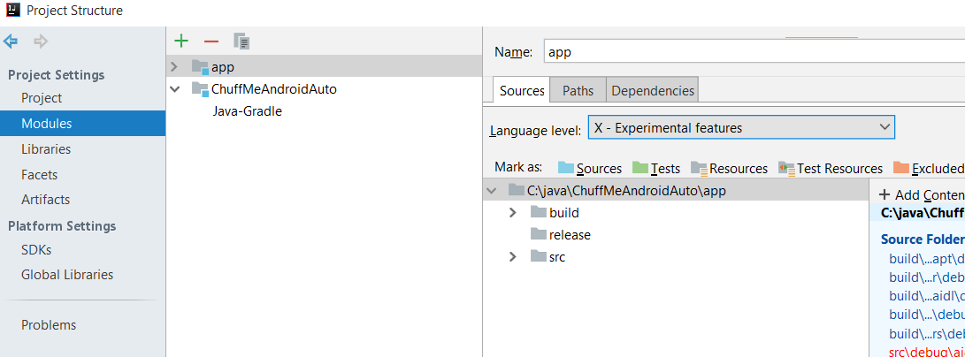

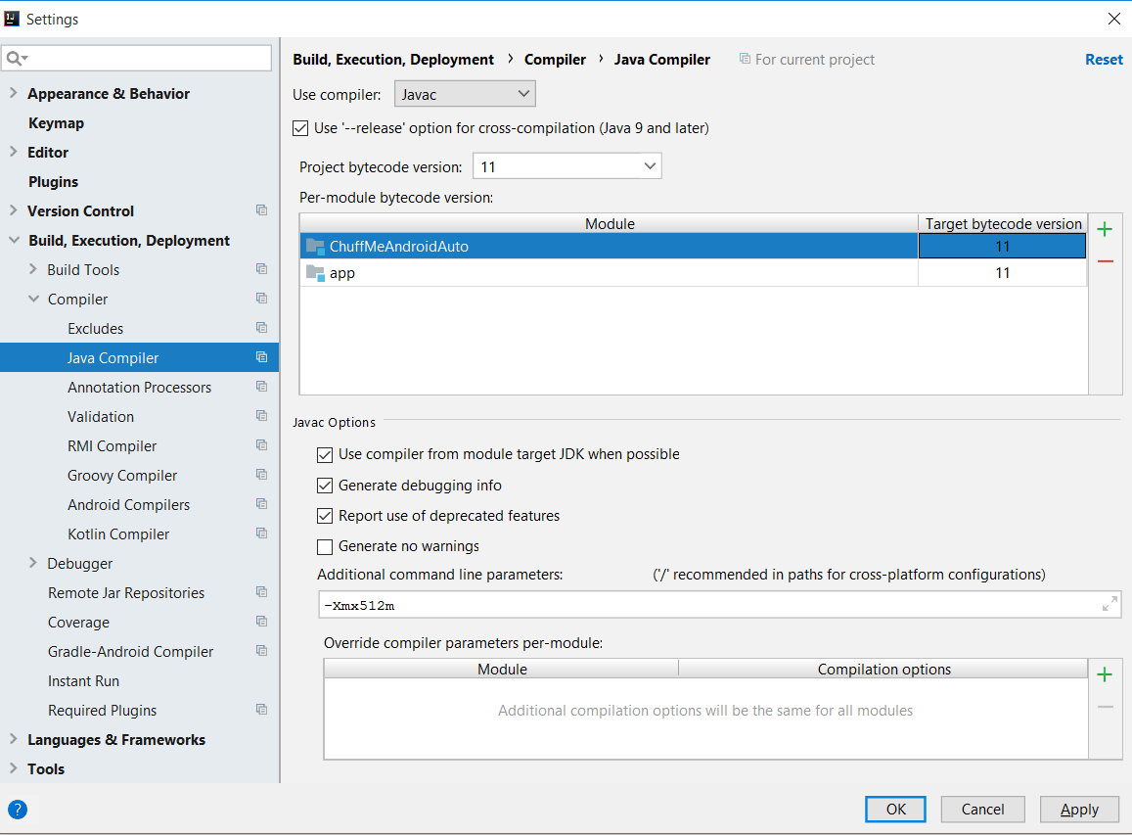

## Could not reserve enough space for object heap

## Import project into IntelliJ from git

First get the new project from git

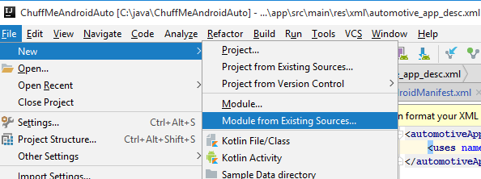

File 🡪 New 🡪Project from existing sources

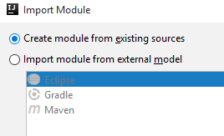

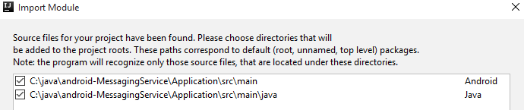

Choose defaults for each then you’ll need a project compiler output:

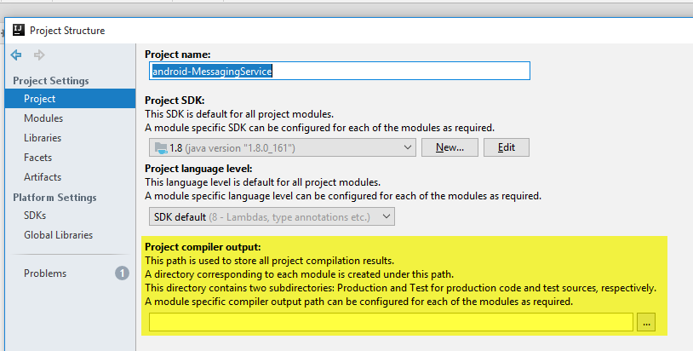

e.g. C:\java\ChuffMeAndroidAuto\build\classes